Scientific Experimentation and Evaluation
Arka Mallick, Daiem Ali,Chun Kwang Tan
Hochschule Bonn-Rhien-Sieg
11.05.2015
Design of robot
The design of the robot is modified from the previous assignment such that we are able to mount the marker on top of the robot. This because the AICISS optical tracking system relies on ceiling-mounted cameras.
Below are pictures depicting how we attached the marker onto the robot.
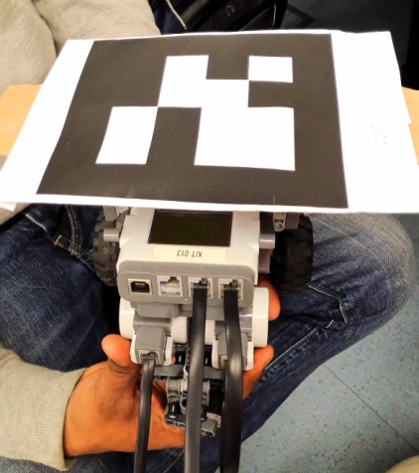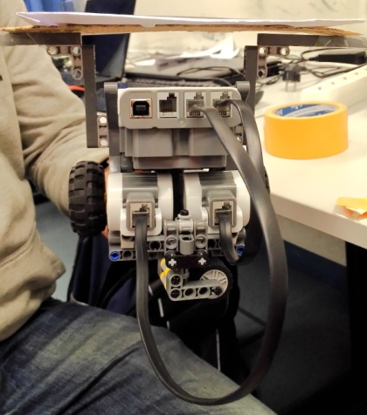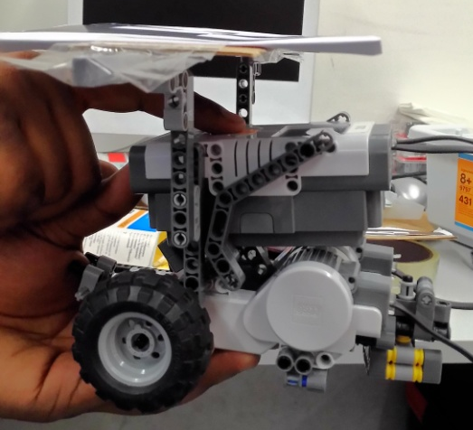
Fig 1, 2, 3 (Views from Front-top, back and side)
The marker is attached in a way that the center of the marker corresponds approximately to a point between the two drive wheels (Fig 3 View from side)
AICISS Optical Tracking System
To retrieve the pose of the center of motion of the robot, we started up the AICISS tracking system.
The AICISS tracking system utilizes a ceiling mounted camera to detect the marker and capture the coordinates of the robot. Coordinates are given in the world frame.
We placed the robot with an area bounded by some tape (as shown in Figure 4). Then, the AICISS tracking system is activated. Readings from the tracking system are stored into a text file.
We conducted this experiment 3 times, with 21 trials each time, and 30 readings per trial.
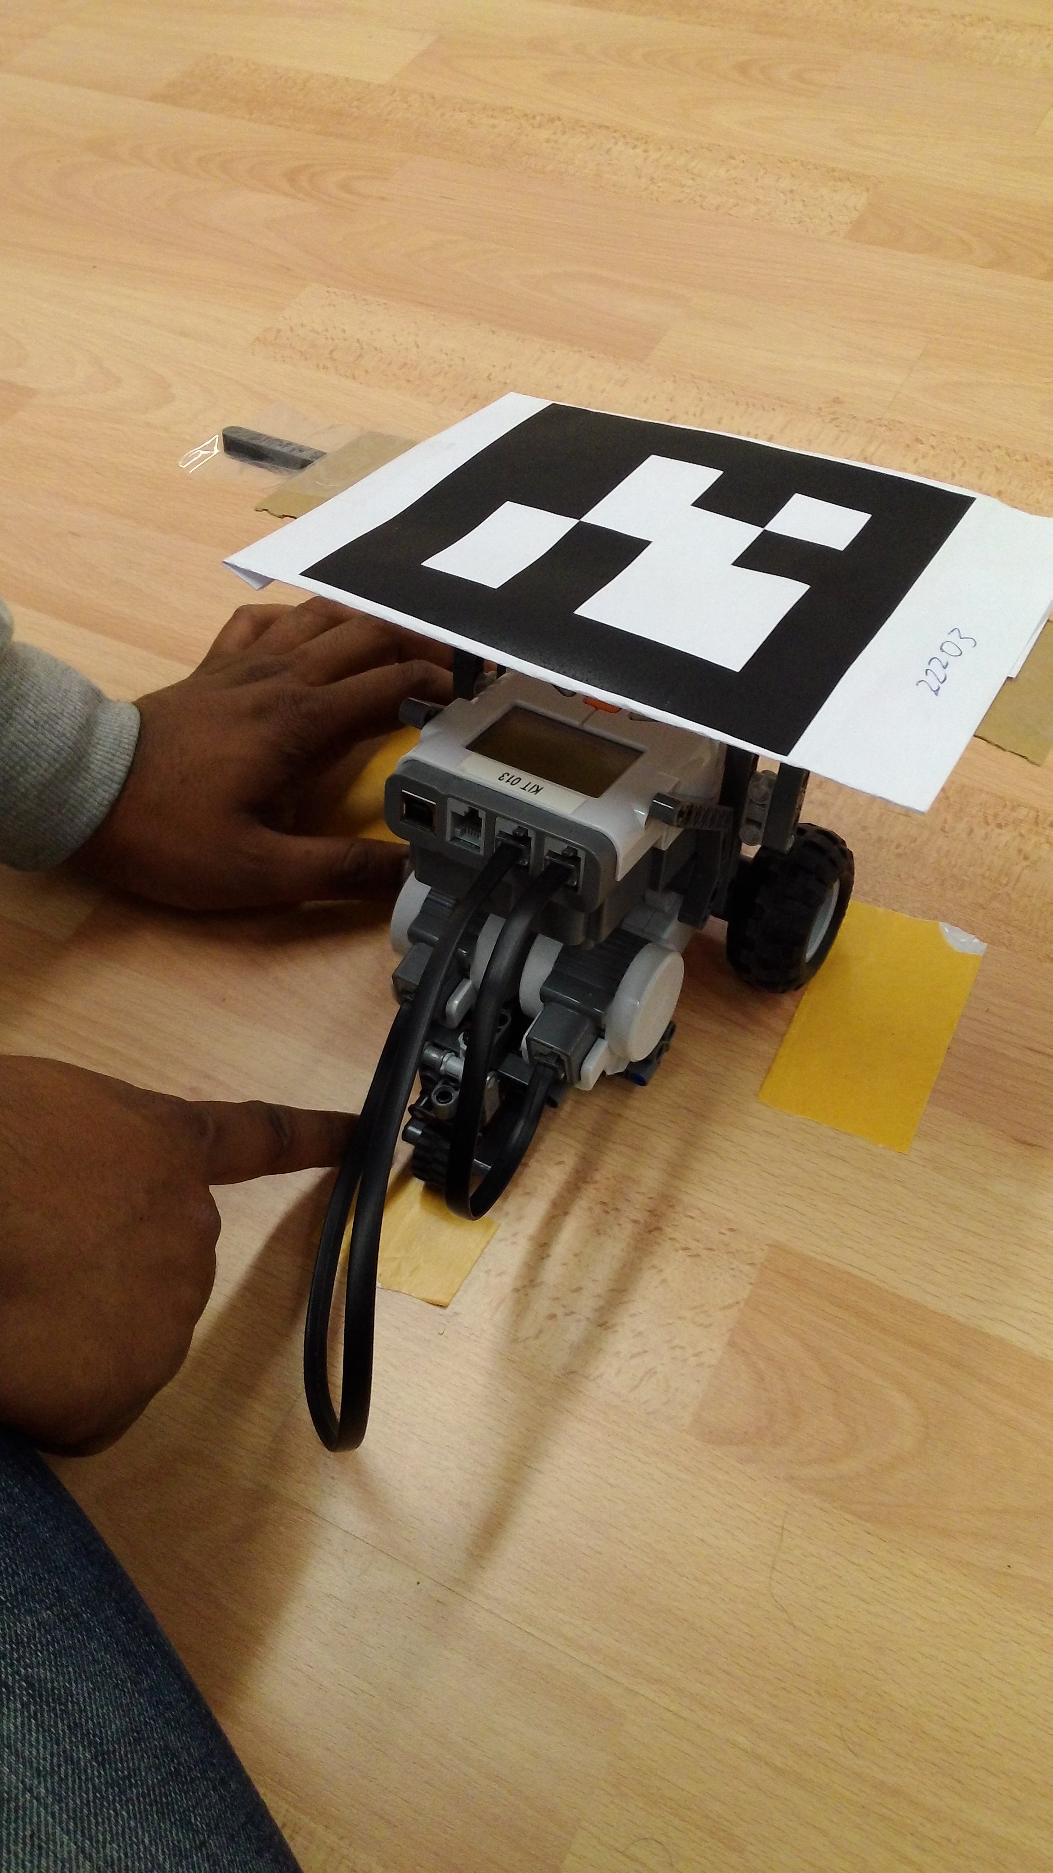
Figure 4: Placement of robot
Estimation of pose measurement error
To estimate the pose measurement error, we calculated the mean and standard deviation of the readings and plotted them. Results are shown in the table and graphs below.
Experiment | Mean (x-coord) | Mean (y-coord) | Stddev (x-coord) | Stddev (y-coord)
1 | -448.37492 | 200.36568 | 2.52009 | 1.16478
2 | -448.74010 | 199.93731 | 1.46121 | 1.20723
3 | -435.56937 | 199.50004 | 37.93840 | 1.92050

Data from the table is plotted against all the readings obtained per experiment for better visualization.
Note that the errorbars denote standard deviation
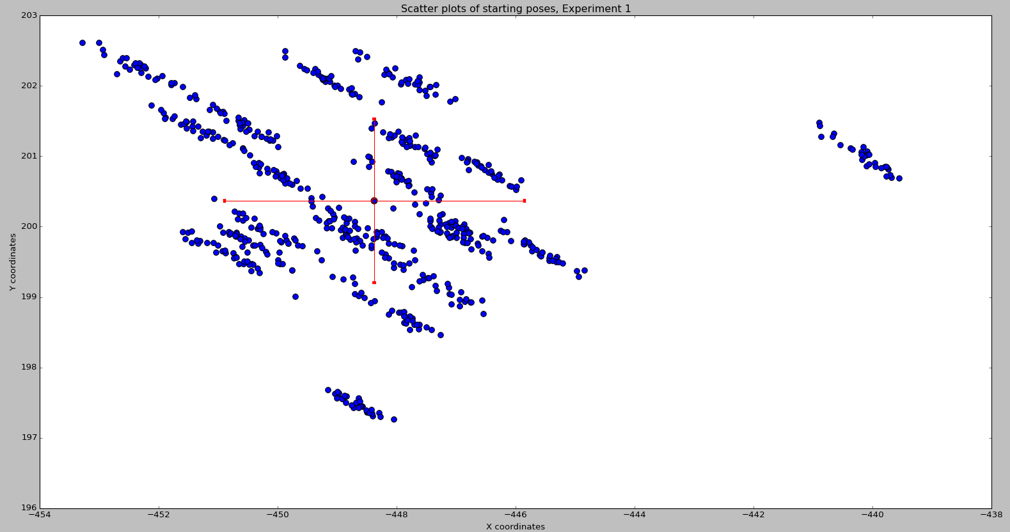
Figure 5: Experiment Run 1
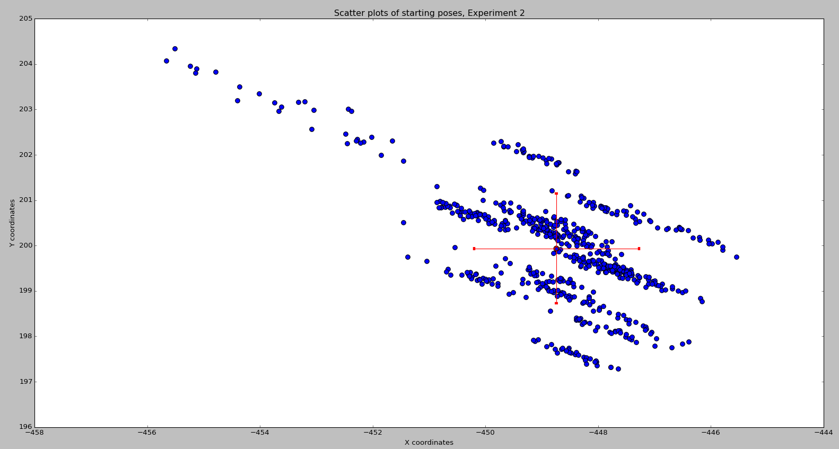
Figure 6: Experiment Run 2

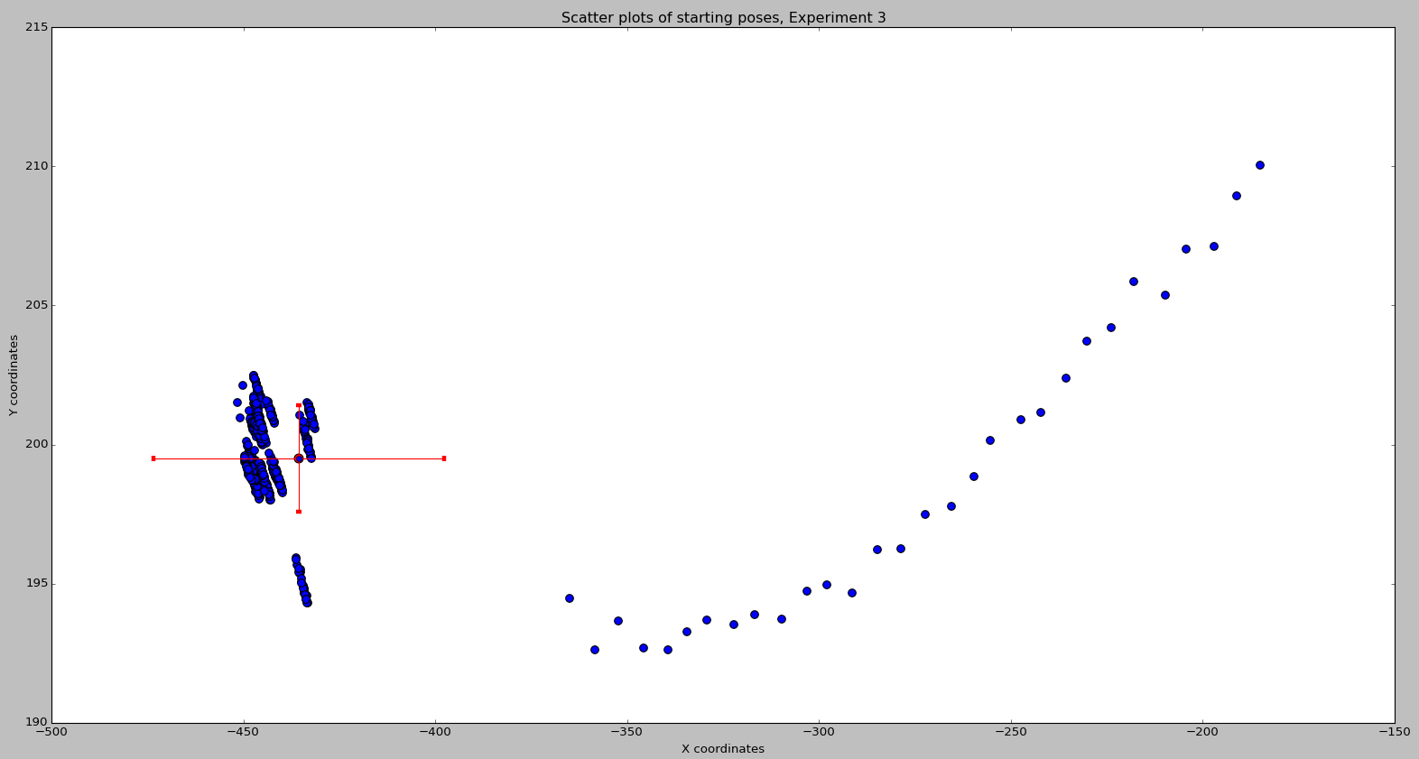
Figure 7: Experiment Run 3
Conclusions to be drawn
From the graphs, it appears that in general, the AICISS tracking system is fairly accurate, with some outliers. In only 1 experiment (Experiment 3), the standard deviation of the x-coordinate spikes. This can be attributed to accidental movement of the robot when the tracking system is active.

